Pokhara University

Level: Bachelor | Semester – Spring | Year : 2009
Programme: BE |  | Full Marks: 100
Course: Engineering Mathematics II |  | Pass Marks: 45
 |  | Time : 3hrs.

Candidates are required to give their answers in their own words as far as practicable.
The figures in the margin indicate full marks.

Attempt all the questions.

 | - Find a equation to the line through (-1,3,2) and perpendicular to the plane x+2y+2z=3, the length of perpendicular and co-ordinate of its foot.  OR  Find the shortest distance between the lines  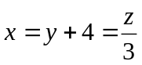 and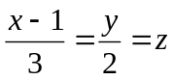.  Find also the equation of shortest distance.  - Find the equation of the sphere one of whose great Circle is  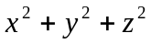=4, x²+y²+z²-2x+4y-6z=11 | 8  7
 | - State and prove Euler’s theorem for homogeneous function of three variables with degree n.  - A rectangle box , open at the top , is to have a volume of 32c.c. Find the dimension of box requiring least material for its construction. | 7  8
 | - Sketch the region of integration 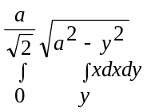and evaluate the integral by reversing the order of integration.  - Find the volume V of the solid bounded by xy plane, the paraboloid 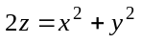 and the cylinder 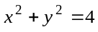 | 7  8
 | - Solve 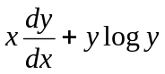=xye^{x}  - Solve the differential equation y"+y'=x | 7  8
 | - Find the solution of the differential equation: 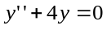,by using power series method.  - Define Legendre’s equation and find its solution.  OR  Solve the following initial value problem: 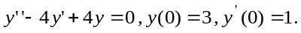 | 7  8
 | - Define Laplace transform. State and prove first shifting theorem of Laplace transform. Using it find Laplace transform of 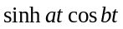  - Define unit step function. State and prove second shifting theorem of Laplace transform. Find 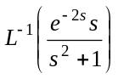  OR  Solve the initial value problem: 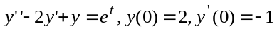, by using Laplace transform. | 8  7
 | Short questions:  - Find the equation of the plane P(1,4,-2) at right angle to OP.  - Solve: 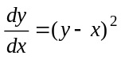.  - Find Laplace transform of the function f(t) = 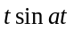.  - Change Cartesian integral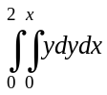, to equivalent polar integral.  - If V = 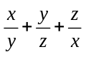 , then find the value of 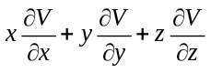 | 5×2

